Reopening Openness to Experience:
A Network Analysis of Four Openness to Experience Inventories
Supplementary Information
SI 1. Technical information about the TMFG algorithm (Massara et al., 2016)
The TMFG algorithm starts from a clique of order 4 (K4 ) and adds nodes in the middle of a 3-clique (T2 move). At each step, the algorithm optimizes the sum of the weights of the edges. T2 is applied to the vertex and face pair that leads to the maximum increase in weights.
TMFG Algorithm:
input :A dense n×n square matrix W with positive weights
output: A sparse matrix, P, a filtered version of W fulfilling the planarity constraint
- C1 ←Tetrahedron, {v1,v2,v3,v4}, with highest overall total weights; // Assign the four triangular faces in C1 to the array T
- T ← {{v1,v2,v3},{v1,v2,v4},{v1,v3,v4},{v2,v3,v4}}; // Put the p − 4 vertices not belonging to C1 in the array V
- V← v5,···,vp ; // Create an empty list of Separators
- S← ∅; // Assign the first tetrahedron to the list of cliques
- C ← C1;
- P ← W(C1,C1);
- Calculate MaxGain for T and V as in Eq.(1) ;
- Calculate BestVertex for T and V as in Eq. (2) ; // Insert p − 4 vertices via T2
- while V is not empty do
- Find the ti ∈ T and vi ∈ V that achieve the maximum in MaxGain ;
- Insert vi into ti // this creates three new triangles ta, tb, tc
- V ← V \ vi;
- T ← (T \{ti})∪{ta,tb,tc};
- Si ←{ti};
- S ← S ∪ Si;
- Ci ←{ti,ta,tb,tc};
- C ← C ∪ Ci;
- P ← P + W (Ci , Ci ) − W (Si , Si );
- Update MaxGain and BestVertex to reflect the changes in T and V ;
- end
- return P;

The resulting TMFG network is a chordal graph. A sparse inverse covariance matrix J that can be associated to the TMFG in such a way that edges of the TMFG correspond to non-zero values of the sparse inverse. The joint probability distribution of n variables $X_{1},…X_{n}$is
$$P\left(X_{1},…X_{n}\right)=\frac{1}{Z}exp⁡(-\sum_{i=1}^{n}{X_{i}{ J}_{i,j}X_{j}})$$
with Z a normalization constant called partition function. The elements of the inverse covariance are associated with the 4-cliques (C) and the 3-cliques separators (S) of the TMFG and can be directly computed form the covariance (see Barfuss et al., 2016, Eqs.4 and 5):
$$J_{i,j}= \sum_{C s.t.\left\{i,j\right\}∈C}{{\left({Σ\left(C\right)}^{-1}\right)}_{i,j}-}\sum_{S s.t.\left\{i,j\right\}∈C}{{\left({Σ\left(S\right)}^{-1}\right)}_{i,j}}$$
Analogously with lasso method, J, is a sparse inverse covariance where non-zero entries correspond to conditionally depended couples of variables.
SI 2. Openness to Experience Inventories with facet, network-identified facet, item, and gradation classification (C = core, I = intermediate, P = peripheral), and description (sorted alphabetically by inventory and then network name).
Inventory | Inventory Facet | Walktrap Facet | Network Name | Gradation | Item
BFAS | Intellect | Self-Assessed Intelligence | I10 | P | I formulate ideas clearly
BFAS | Intellect | Self-Assessed Intelligence | It1 | C | I have difficulty understanding abstract ideas
BFAS | Intellect | Intellectual Interests | It2 | C | I avoid philosophical discussions
BFAS | Intellect | Self-Assessed Intelligence | It3 | C | I avoid difficult reading material
BFAS | Intellect | Intellectual Curiosity | It4 | C | I like to solve complex problems
BFAS | Intellect | Self-Assessed Intelligence | It5 | I | I am quick to understand things
BFAS | Intellect | Self-Assessed Intelligence | It6 | P | I can handle a lot of information
BFAS | Intellect | Self-Assessed Intelligence | It7 | P | I have a rich vocabulary
BFAS | Intellect | Self-Assessed Intelligence | It8 | P | I think quickly
BFAS | Intellect | Self-Assessed Intelligence | It9 | C | I learn things slowly
BFAS | Openness | Fantasy | O10 | I | I seldom daydream
BFAS | Openness | Aesthetic Appreciation | Op1 | C | I believe in the importance of art
BFAS | Openness | Aesthetic Appreciation | Op2 | I | I enjoy the beauty of nature
BFAS | Openness | Intellectual Curiosity | Op3 | C | I love to reflect on things
BFAS | Openness | Aesthetic Appreciation | Op4 | C | I do not like poetry
BFAS | Openness | Aesthetic Appreciation | Op5 | I | I seldom notice the emotional aspects of paintings and pictures
BFAS | Openness | Imaginative | Op6 | I | I need a creative outlet
BFAS | Openness | Aesthetic Appreciation | Op7 | C | I see beauty in things that others might not notice
BFAS | Openness | Openness to Emotions | Op8 | I | I get deeply immersed in music
BFAS | Openness | Fantasy | Op9 | P | I seldom get lost in thought
HEXACO | Creativity | Imaginative | Cr1 | P | I would like a job that requires following a routine rather than being creative
HEXACO | Creativity | Imaginative | Cr2 | C | I would enjoy creating a work of art, such as a novel, a song, or a painting
HEXACO | Creativity | Imaginative | Cr3 | C | I don't think of myself as the artistic or creative type
HEXACO | Creativity | Imaginative | Cr4 | I | People have often told me that I have a good imagination
HEXACO | Aesthetic Appreciation | Aesthetic Appreciation | HA1 | C | I would be quite bored by a visit to an art gallery
HEXACO | Aesthetic Appreciation | Aesthetic Appreciation | HA2 | I | I wouldn't spend my time reading a book of poetry
HEXACO | Aesthetic Appreciation | Aesthetic Appreciation | HA3 | I | If I had the opportunity, I would like to attend a classical music concert
HEXACO | Aesthetic Appreciation | Aesthetic Appreciation | HA4 | P | Sometimes I like to just watch the wind as it blows through the trees
HEXACO | Inquisitiveness | Intellectual Interests | Iq1 | I | I'm interested in learning about the history and politics of other countries
HEXACO | Inquisitiveness | Intellectual Interests | Iq2 | P | I enjoy looking at maps of different places
HEXACO | Inquisitiveness | Intellectual Interests | Iq3 | C | I would be very bored by a book about the history of science and technology
HEXACO | Inquisitiveness | Intellectual Interests | Iq4 | C | I've never really enjoyed looking through an encyclopedia
HEXACO | Unconventionality | Intellectual Interests | Uc1 | I | I think that paying attention to radical ideas is a waste of time
HEXACO | Unconventionality | Intellectual Interests | Uc2 | C | I find it boring to discuss philosophy
HEXACO | Unconventionality | Imaginative | Uc3 | P | I think of myself as a somewhat eccentric person
HEXACO | Unconventionality | Diversity | Uc4 | P | I like people who have unconventional views
NEO | Actions | Intellectual Curiosity | Ac1 | P | learn/develop new hobbies
NEO | Actions | Diversity | Ac2 | P | variety/spice of life
NEO | Actions | Diversity | Ac3 | P | try foreign foods
NEO | Actions | Variety-Seeking | Ac4 | I | set in ways
NEO | Actions | Variety-Seeking | Ac5 | P | vacation to tried and true spot
NEO | Actions | Variety-Seeking | Ac6 | P | prefer time in familiar surroundings
NEO | Actions | Variety-Seeking | Ac7 | I | prefer old methods
NEO | Actions | Variety-Seeking | Ac8 | P | same route to go someplace
NEO | Fantasy | Imaginative | Fa1 | C | active imagination
NEO | Fantasy | Imaginative | Fa2 | I | active fantasy
NEO | Fantasy | Imaginative | Fa3 | I | letting a fantasy or daydream develop
NEO | Fantasy | Fantasy | Fa4 | I | don't waste time daydreaming
NEO | Fantasy | Fantasy | Fa5 | P | keep thoughts on realistic lines
NEO | Fantasy | Fantasy | Fa6 | P | difficulty letting my mind wander
NEO | Fantasy | Fantasy | Fa7 | P | concentrate on work rather than daydreams
NEO | Fantasy | Fantasy | Fa8 | P | rarely enjoy make believe
NEO | Feelings | Non-traditionalism | Fe1 | P | don't pay attention to feelings
NEO | Feelings | Non-traditionalism | Fe2 | I | don't notice feelings environments produce
NEO | Feelings | Openness to Emotions | Fe3 | I | wide range of Openness to Emotions
NEO | Feelings | Openness to Emotions | Fe4 | I | few strong Openness to Emotions
NEO | Feelings | Openness to Emotions | Fe5 | I | scents or places evoke strong moods
NEO | Feelings | Openness to Emotions | Fe6 | P | strong Openness to Emotions make life interesting
NEO | Feelings | Openness to Emotions | Fe7 | P | easy to empathize
NEO | Feelings | Openness to Emotions | Fe8 | P | feelings are important to me
NEO | Ideas | Intellectual Interests | Id1 | C | enjoy playing with abstract ideas
NEO | Ideas | Intellectual Interests | Id2 | C | philosophy is boring
NEO | Ideas | Intellectual Interests | Id3 | C | lose interest when talking about abstract/theoretical matters
NEO | Ideas | Intellectual Curiosity | Id4 | I | enjoy "mind twister" puzzles
NEO | Ideas | Intellectual Curiosity | Id5 | I | like solving problems/puzzles
NEO | Ideas | Intellectual Curiosity | Id6 | C | a lot of curiosity
NEO | Ideas | Intellectual Curiosity | Id7 | C | broad range of intellectual interests
NEO | Ideas | Intellectual Interests | Id8 | C | no interest in thinking about the human condition
NEO | Aesthetics | Aesthetic Appreciation | NA1 | C | not interested in the arts
NEO | Aesthetics | Aesthetic Appreciation | NA2 | C | poetry does not effect me
NEO | Aesthetics | Aesthetic Appreciation | NA3 | C | get a chill from poetry or a work of art
NEO | Aesthetics | Aesthetic Appreciation | NA4 | I | ballet is boring
NEO | Aesthetics | Aesthetic Appreciation | NA5 | C | interested in patterns found in art and nature
NEO | Aesthetics | Aesthetic Appreciation | NA6 | P | enjoy poetry with feelings rather than images/story lines
NEO | Aesthetics | Openness to Emotions | NA7 | I | get absorbed into music
NEO | Aesthetics | Openness to Emotions | NA8 | I | genres of music are fascinating to me
NEO | Values | Non-traditionalism | Va1 | P | religious authorities should make decisions on moral issues
NEO | Values | Non-traditionalism | Va2 | P | people should know what they're doing by 25
NEO | Values | Non-traditionalism | Va3 | C | controversial speakers will only confuse people
NEO | Values | Diversity | Va4 | I | law changes should reflect the needs of the changing world
NEO | Values | Diversity | Va5 | P | broad-minded of other's lifestyles
NEO | Values | Diversity | Va6 | P | right and wrong differ for people
NEO | Values | Variety-Seeking | Va7 | P | better to stick to principles than being open-minded
NEO | Values | Non-traditionalism | Va8 | I | honor traditional values
Woo et al. | Curiosity | Intellectual Interests | Cu1 | P | I have never really been interested in science
Woo et al. | Curiosity | Intellectual Curiosity | Cu2 | I | I like to analyze things instead of taking them at face value
Woo et al. | Curiosity | Intellectual Curiosity | Cu3 | I | I love to do experiments and see the results
Woo et al. | Curiosity | Intellectual Curiosity | Cu4 | C | I continually strive to uncover information about topics that are new to me
Woo et al. | Curiosity | Intellectual Curiosity | Cu5 | I | I try to learn something new every day
Woo et al. | Curiosity | Non-traditionalism | Cu6 | P | I don’t like trying new things and would rather stick with what I know
Woo et al. | Curiosity | Non-traditionalism | Cu7 | C | I have no interest in learning new information
Woo et al. | Curiosity | Non-traditionalism | Cu8 | I | I seldom seek new opportunities to extend my knowledge
Woo et al. | Curiosity | Diversity | Cu9 | P | In a quiz I like to know what the answers are if I get the questions wrong
Woo et al. | Depth | Intellectual Interests | Dp1 | C | Sometimes I avoid getting involved in philosophical discussions
Woo et al. | Depth | Intellectual Interests | Dp2 | I | I’m happiest when conversations are practical rather than philosophical
Woo et al. | Depth | Intellectual Interests | Dp3 | C | I am always interested in learning more about philosophy
Woo et al. | Depth | Intellectual Curiosity | Dp4 | I | I take the time to reflect on my own thoughts and actions
Woo et al. | Depth | Aesthetic Appreciation | Dp5 | P | For me personal growth is more important than success
Woo et al. | Depth | Intellectual Curiosity | Dp6 | I | For me, there is nothing better than taking the time to think deeply about something
Woo et al. | Depth | Aesthetic Appreciation | Dp7 | P | I am fascinated by meditation and processes which encourage one to look inward
Woo et al. | Depth | Non-traditionalism | Dp8 | C | I believe in-depth discussions are a complete waste of time
Woo et al. | Depth | Intellectual Interests | Dp9 | C | I regard philosophy as a disease of the idle
Woo et al. | Intellectual Efficiency | Self-Assessed Intelligence | Ie1 | C | Tasks that require a lot of thinking confuse me easily
Woo et al. | Intellectual Efficiency | Self-Assessed Intelligence | Ie2 | I | I am a slow learner
Woo et al. | Intellectual Efficiency | Self-Assessed Intelligence | Ie3 | P | I always have difficulty applying new concepts
Woo et al. | Intellectual Efficiency | Self-Assessed Intelligence | Ie4 | P | I often need people to explain things to me
Woo et al. | Intellectual Efficiency | Self-Assessed Intelligence | Ie5 | C | I am usually not very quick in my thinking but have strengths in other areas
Woo et al. | Intellectual Efficiency | Self-Assessed Intelligence | Ie6 | P | I have to read complex information several times before I fully understand it
Woo et al. | Intellectual Efficiency | Self-Assessed Intelligence | Ie7 | P | I need things explained to me only once
Woo et al. | Intellectual Efficiency | Self-Assessed Intelligence | Ie8 | C | I am very quick at processing information
Woo et al. | Intellectual Efficiency | Self-Assessed Intelligence | Ie9 | P | I grasp scientific theories easily
Woo et al. | Ingenuity | Self-Assessed Intelligence | Ig1 | I | I'm hopeless with inventing new things
Woo et al. | Ingenuity | Self-Assessed Intelligence | Ig2 | P | I rarely take an idea and apply it in a new way
Woo et al. | Ingenuity | Self-Assessed Intelligence | Ig3 | C | I avoid situations where I might have to come up with something new
Woo et al. | Ingenuity | Imaginative | Ig4 | I | Compared to other people I don’t think I am very creative
Woo et al. | Ingenuity | Intellectual Curiosity | Ig5 | P | I improvise if I don't have the right tool for a job
Woo et al. | Ingenuity | Imaginative | Ig6 | C | I like coming up with imaginative plans
Woo et al. | Ingenuity | Imaginative | Ig7 | C | I would rather have a job that involves creativity than one that doesn’t
Woo et al. | Ingenuity | Imaginative | Ig8 | I | I can develop inventive ideas of high quality
Woo et al. | Ingenuity | Imaginative | Ig9 | P | People come to me if they are stuck for fresh ideas
Woo et al. | Tolerance | Intellectual Interests | To1 | I | I like to hear different people's views on political issues
Woo et al. | Tolerance | Non-traditionalism | To2 | C | I think it is rude when others speak in a language I can't understand
Woo et al. | Tolerance | Diversity | To3 | I | I understand that people can have different attitudes toward certain things than I do
Woo et al. | Tolerance | Non-traditionalism | To4 | I | Immigrants really irritate me
Woo et al. | Tolerance | Diversity | To5 | I | Like most people, I am open to listening to what others have to say
Woo et al. | Tolerance | Diversity | To6 | P | I enjoy experiencing the rituals associated with different religions
Woo et al. | Tolerance | Diversity | To7 | I | I learn a great deal from people with differing beliefs
Woo et al. | Tolerance | Diversity | To8 | C | I enjoy diversity in the community
Woo et al. | Tolerance | Variety-Seeking | To9 | P | I prefer to visit countries where they speak my language
Woo et al. | Aesthetics | Aesthetic Appreciation | WA1 | I | I think viewing art is a waste of time
Woo et al. | Aesthetics | Aesthetic Appreciation | WA2 | C | Art bores me
Woo et al. | Aesthetics | Aesthetic Appreciation | WA3 | P | I don't find Classical Ballet interesting
Woo et al. | Aesthetics | Aesthetic Appreciation | WA4 | I | I don't find literature especially interesting
Woo et al. | Aesthetics | Aesthetic Appreciation | WA5 | C | I have a passion for art
Woo et al. | Aesthetics | Aesthetic Appreciation | WA6 | C | I enjoy art exhibitions
Woo et al. | Aesthetics | Aesthetic Appreciation | WA7 | C | I see the beauty in art when others do not
Woo et al. | Aesthetics | Aesthetic Appreciation | WA8 | I | If I see artwork I like in a gallery, I will visit it more than once to fully appreciate it
Woo et al. | Aesthetics | Openness to Emotions | WA9 | C | I have been touched emotionally by a great musical performance

Note. For the NEO, the items are reworded phrases that capture the sense of the item, not the exact items from the NEO-PI-3 inventory.

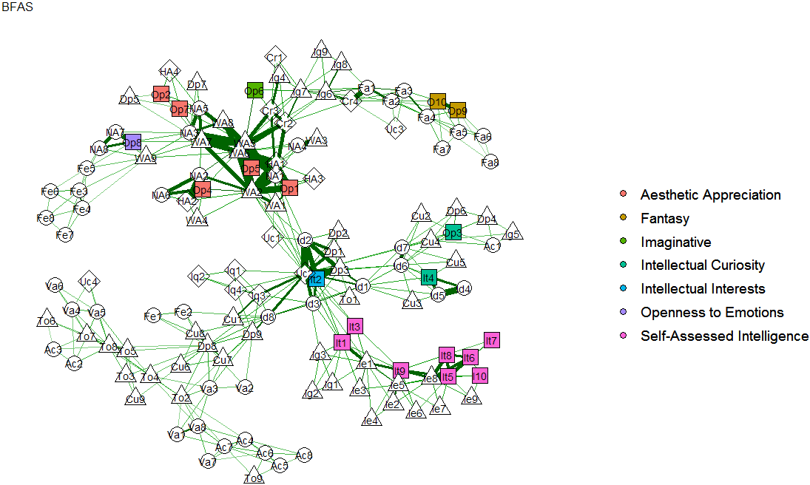
SI 3. Larger view of BFAS inventory conceptual coverage (top-left, Figure 2; see SI 1 for item descriptions)

SI 4. Larger view of HEXACO-100 inventory conceptual coverage (top-right, Figure 2; see SI 1 for item descriptions)
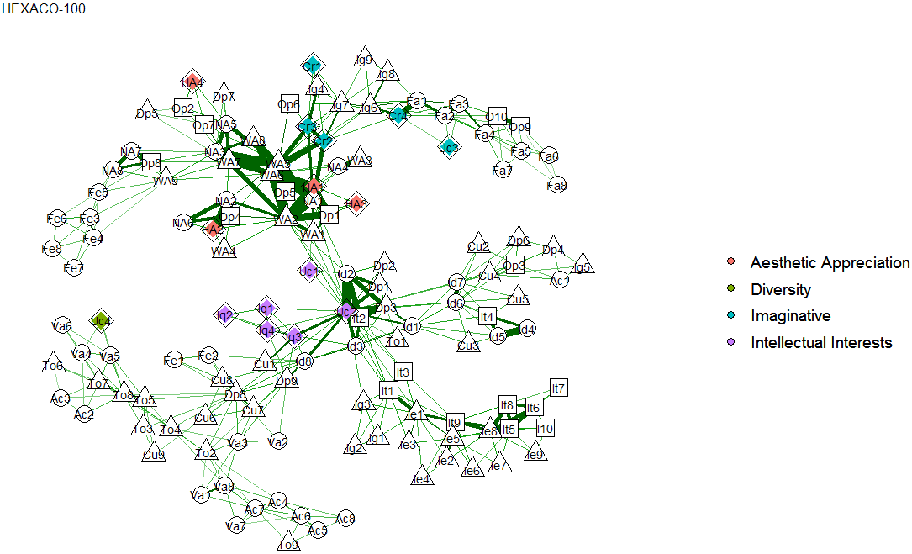
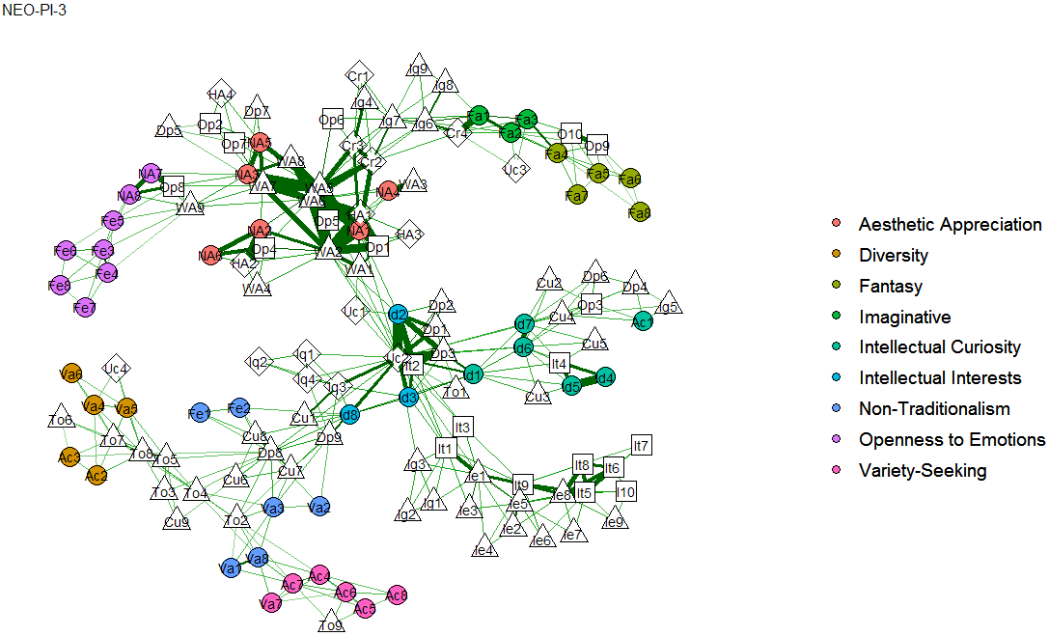
SI 5. Larger view of NEO-PI-3 inventory conceptual coverage (bottom-left, Figure 2; see SI 1 for item descriptions)

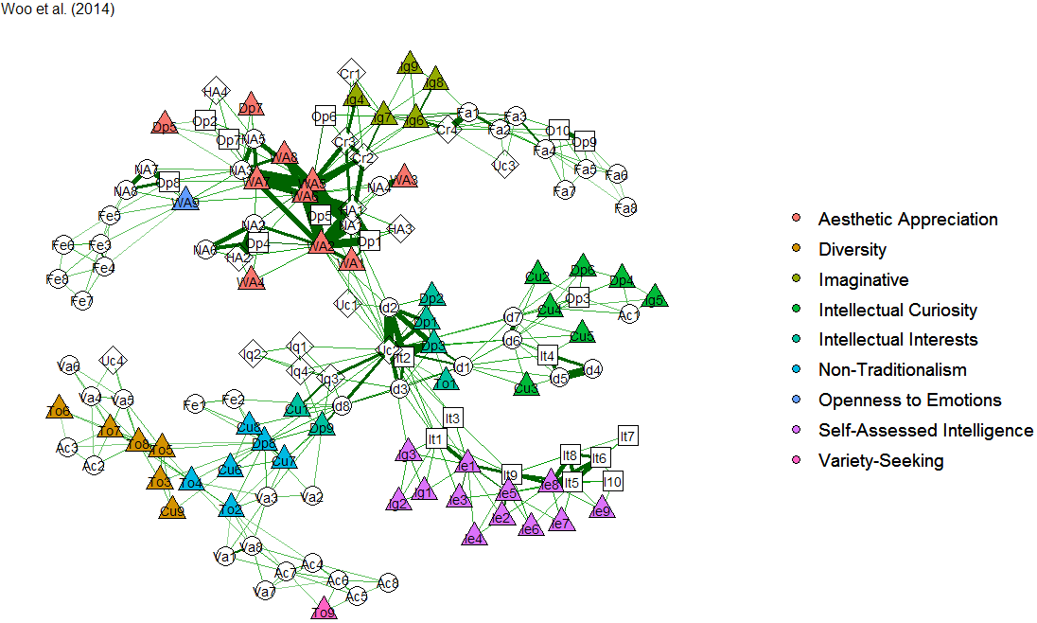
SI 6. Larger view of Woo et al.’s (2014) Openness to Experience inventory conceptual coverage (bottom-right, Figure 2; see SI 1 for item descriptions)

SI 7. MANOVA and Box’s M tests for analysis of group differences and equal covariances

 | MANOVA |  |  |  |  |  | Box’s M
Statistic | Pillai |  | F (df) | Pillai |  | F (df) | F (df)
Sample | 1 |  |  | 2 |  |  | 1
1 (n = 176) | — | — |  | — | — |  | —
2 (n =108) | .650 | 1.95 (1, 282) |  | — | — |  | —
3 (n = 518) | .675 | 8.34 (1, 692) |  | .614 | 5.62 (1, 624) |  | 1.292 (9591)
Note: MANOVA with all three samples, F_{(2, 799}) = 4.43, Pillai = .960, p < .001. All p’s < .001***.

SI 8. R code for all analyses in the manuscript
###Reopening Openness to Experience:
###A Network Analysis of Four Openness to Experience Inventories

###install necessary packages
devtools::install_github("AlexChristensen/NetworkToolbox")
install.packages(qgraph)
install.packages(igraph)

###load packages
library(NetworkToolbox)
library(qgraph)
library(igraph)

###read in data
data <- read.csv(file.choose(),header=TRUE,sep=",")

###construct network
tmfg <- TMFG(data)$A

###perform walktrap community detection algorithm
walktrap <- convert2igraph(tmfg)

#check walktrap robustness
rand<-.Random.seed
walkcheck<-matrix(0,nrow=138,ncol=10)

for(i in 1:10)
{
set.seed(rand[i])
walkcheck[,i]<-walktrap.community(walktrap)$membership
}

set.seed(0)
wc<-walktrap.community(walktrap)
wc$membership
max(wc$membership)

###name communities
for (i in 1:length(wc$membership))
if (wc$membership[i] == 1)
{wc$membership[i]<-c("Intellectual Curiosity")
}else if (wc$membership[i] == 2)
{wc$membership[i]<-c("Aesthetic Appreciation")
}else if (wc$membership[i] == 3)
{wc$membership[i]<-c("Self-Assessed Intelligence")
}else if (wc$membership[i] == 4)
{wc$membership[i]<-c("Openness to Emotions")
}else if (wc$membership[i] == 5)
{wc$membership[i]<-c("Intellectual Interests")
}else if (wc$membership[i] == 6)
{wc$membership[i]<-c("Imaginative")
}else if (wc$membership[i] == 7)
{wc$membership[i]<-c("Non-Traditionalism")
}else if (wc$membership[i] == 8)
{wc$membership[i]<-c("Diversity")
}else if (wc$membership[i] == 9)
{wc$membership[i]<-c("Variety-Seeking")
}else if (wc$membership[i] == 10)
{wc$membership[i]<-c("Fantasy")}

###Full Network
layout(matrix(c(1,1)))
shapes<-c(rep("circle",48),rep("square",20),rep("diamond",16),rep("triangle",54))
plot.ega <- qgraph(tmfg, label.prop=1.5, layout = "spring", vsize = 2.5, esize = 10, groups = as.factor(wc$membership),GLratio=1.5,shape=shapes,palette="ggplot2")

####Layout the four Openness to Experience inventories
layout(matrix(c(1,3,2,4),nrow=2))

#BFAS Network
BFAS<-as.factor(c(rep(NA,48),wc$membership[49:68]))
plot.egab <- qgraph(tmfg, title = "BFAS", groups = BFAS, layout = "spring", vsize = 4, esize = 10,GLratio=1.5,labels=FALSE,shape=shapes,palette="ggplot2")

#HEXACO Network
HEX<-as.factor(c(rep(NA,68),wc$membership[69:84]))
plot.egah <- qgraph(tmfg, title = "HEXACO-100", groups = HEX, layout = "spring", vsize = 4, esize = 10,GLratio=1.5,labels=FALSE,shape=shapes,palette="ggplot2")

#NEO Network
NEO<-as.factor(wc$membership[1:48])
plot.egan <- qgraph(tmfg, title = "NEO-PI-3", groups = NEO, layout = "spring", vsize = 4, esize = 10,GLratio=1.5,labels=FALSE,shape=shapes,palette="ggplot2")

#Woo Network
WOO<-as.factor(c(rep(NA,84),wc$membership[85:138]))
plot.egaw <- qgraph(tmfg, title = "Woo et al. (2014)", groups = WOO, layout = "spring", vsize = 4, esize = 10, GLratio=1.5,labels=FALSE,shape=shapes,palette="ggplot2")

#Supplementary
#BFAS Network
layout(matrix(c(1,1)))
BFAS<-as.factor(c(rep(NA,48),wc$membership[49:68]))
plot.egab <- qgraph(tmfg, title="BFAS",label.prop=1.5,groups = BFAS, layout = "spring", vsize = 2.5, esize = 10,GLratio=1.5,shape=shapes,palette="ggplot2")

#HEXACO Network
HEX<-as.factor(c(rep(NA,68),wc$membership[69:84]))
plot.egah <- qgraph(tmfg, title="HEXACO-100",label.prop=1.5,groups = HEX, layout = "spring", vsize = 2.5, esize = 10,GLratio=1.5,shape=shapes,palette="ggplot2")

#NEO Network
NEO<-as.factor(wc$membership[1:48])
plot.egan <- qgraph(tmfg, title="NEO-PI-3",label.prop=1.5,groups = NEO, layout = "spring", vsize = 2.5, esize = 10,GLratio=1.5,shape=shapes,palette="ggplot2")

#Woo Network
WOO<-as.factor(c(rep(NA,84),wc$membership[85:138]))
plot.egaw <- qgraph(tmfg, title="Woo et al. (2014)",label.prop=1.5,groups = WOO, layout = "spring", vsize = 2.5, esize = 10, GLratio=1.5,shape=shapes,palette="ggplot2")

